Application Build-out Document
Application Name:EMC
DOCUMENT HISTORY:
Please update the table below if you have made any changes to this document.
Version | Date | Last Update By:
1.0 | 5/19/2010 | Chitaranjan Biswal
1.1 | 06/22/2010 | Chitaranjan Biswal

SERVER DETAILS:
Please list all the servers where the application will be installed.
NAME | Environment | ROLE | DOMAIN | COMMENTS
KSEMCMART01 | UAT1 | SQL | PARTTEST | EMCCORE
TK3XLIRSQLU103 | UAT1 | SQL | PARTTEST | EMC
TK3XEMCSQLU201 | UAT2 | SQL | PARTTEST | EMCCORE
TK5XEMCMART04 | Production | SQL | PARTNERS | EMCCORE
TK5XEMCMART05 | Production | SQL | PARTNERS | EMCCORE
TK5XSABMART1 | Production | SQL | PARTNERS | EMC
TK5XSABMART1 | Production | SQL | PARTNERS | EMC

APPLICATION ARCHITECTURE:

Platform Name | Services and Technologies | Clustering Setup | Cluster Tech
Primary SQL | Win2008, Microsoft SQL Server 2008 - Enterprise Edition (64-bit) | Active/Inactive | Failover clustering

Components
Component | Description
AppSupport | Contains tier-2 support procedures that support the Entitlement database environment.
Entitlement | Source system for Entitlement information
Warehouse | LIR Warehouse database is used as the primary source for agreement and purchase information that is used for calculating entitlements. Warehouse is also used as a data source for most of the EMC reporting procs (which return data about shipments, training vouchers, agreements, etc to the UI).

Connectors:

Connector Name | Connector Tech | Source Component | Target Component | Connector Description
CSC UI | ADO.NET |  | Stored Proc | CSC web site
TSC UI | ADO.NET |  | Stored Proc | TSC Web Site
LIR Warehouse | SQL | t-SQL |  | Entitlement Data Source
LID DB (MVLS) | SQL | t-SQL |  | Direct access to entitlement
DAS (TSC) | ADO.NET |  | Stored Proc | Middle Tier used by TSC
eOpen | ADO |  | Stored Proc | UI for eOpen
SMC | DTS |  | Data | Sync jobs

PRE INSTALLATION TASKS:
Please list all the tasks that need to be completed prior to performing the application installation. This might include but not limited to sending notification or taking backups or starting or stopping any services.
Step |  | Server/ Activity |  |  | Step Instructions
 |  | KSEMCMART01 |  |  | Install Microsoft Windows server 2008 Enterprise(Service Pack 2 and System Type:x64)
 |  |  |  |  | Install Microsoft Sql Server 2008 Enterprise(Service Pack 1 and x64 bit)
 |  |  |  |  | Make sure the SQL Service/Agent should run in the service account (parttest\UATCORE1)
 | KCT’s for ITSM tickets
 | Application |  | KCT | Description of Task |  | Server | Time taken | Contact | Comments
 | EMC |  | KCT0001792 | F/R and Rename the server |  | <ServerName> | 1 day | GCO | Coordinate with GCO, after raising an ITSM ticket. Actual time may vary
 |  |  | KCT0001792 |  |  | Mention the server name based on the environment | 1 day | GCO
 |  |  | N/A | Validate Servers after rebuild |  | <New Server Name> | 2 hrs | SBE | Work with GCO to fix any issues. Actual time may vary depending upon issues detected
 |  |  | KCT0000099 | Assign Static IP (Both for EFL and EBL IP's, use the same KCT) |  | <ServerName> | 1 day | GCO | Coordinate with GCO, after raising an ITSM ticket. Actual time may vary
 |  |  | KCT0000099 |  |  | Mention the server name based on the environment | 1 day | GCO
 |  |  | KCT0000542 | Add/Disable EFL in VIP |  | <ServerName> | 1 day | GCO | Coordinate with GCO, after raising an ITSM ticket. Actual time may vary
 |  |  | KCT0000542 |  |  | Mention the server name based on the environment | 1 day | GCO
 |  |  | KCT0000542 | Enable EFL in VIP |  | <ServerName> | 30 - 60 mins | GCO | Coordinate with GCO, after raising an ITSM ticket
 |  |  | KCT0000542 |  |  | Mention the server name based on the environment | 30 - 60 mins | GCO | Coordinate with GCO, after raising an ITSM ticket
 |  |  | KCT0000301 | Apply Code as part of Quarterly Release |  | <ServerName> | 2 hours | SBE | Includes time taken to backup, Octopus Config Preparation, post-config changes and Octopus Deployment

INSTALLATION EXECUTION STEPS:
Provide step-by-step tasks to install this application on all servers listed above. Please include as many screenshots as required. The goal is to create a step-by-step process that anyone without application knowledge can still execute and successfully install the application in this environment.
Step | Server | Step Instructions
100 | KSEMCMART01 | Copy Scrubbed Backups from SE Team  - APPSUPPORT  - EMCINTERFACE  - ENTITLEMENT  - STAGING  - Warehouse  - SQLOPSDB  - Tags
101 | KSEMCMART01 | Restore All Databases on KSEMCMART01  Change Database Owner  - Please run the following query in order to change the database owner for all databases except system databases to ‘sa’  SET QUOTED_IDENTIFIER OFF  SET NOCOUNT ON  Print 'Starting UpdateDBOwner.sql - Changing Database Owner to sa'  Declare @dbname as varchar(200)  Declare @sqltext as varchar(8000)  Create table #Temp1  (  dbname sysname  )  Select @sqltext='SELECT name FROM sys.sysdatabases WHERE sid!=0x01'  Insert into #temp1  execute(@sqltext)  DECLARE ResCur Cursor  for  Select dbname from #temp1  Open ResCur  Fetch NEXT FROM ResCur INTO @dbname  select @sqltext=""  While (@@FETCH_STATUS <> -1)  BEGIN  select @sqltext = 'use [' + @dbname+']'+char(10)+'exec SP_CHANGEDBOWNER ''SA'''  Print 'Changed database '+@dbname+' Owner to sa'  execute( @sqltext )  Fetch NEXT FROM ResCur INTO @dbname  END  CLOSE ResCur  DEALLOCATE ResCur  --select * from #temp1  Drop table #temp1  Print 'Exiting UpdateDBOwner.sql'  Copy All Folders in E Drive  - @CMD – It contains many bat files which normally kicks of jobs in the repository servers.  - @SSIS – It contains SSIS Packages called by various jobs  - Joblogs – All Job related logs are stored here.  - Joblogs_Archive – All Job logs are archived here.
102 | KSEMCMART01 | Run below Configuration Script once restoration done for all databases
103 | KSEMCMART01 | AppSupport Script (EMCCORE)  - Open the script and update the correct servers name.  - Run AppSupport Script on EMCCORE server(KSEMCMART01)  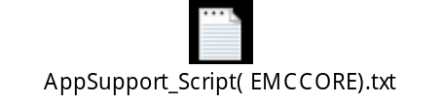
104 | TK3XLIRSQLU103 | AppSupport Script (SABMART)  - Open the script and update the correct servers .  - Run AppSupport Script (SABMART) on TK3XLIRSQLU103  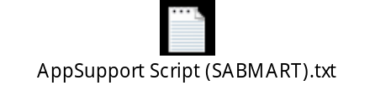
105 | KSEMCMART01 | MSLWControl Parameters (EMCCORE)  - Open the script and update the correct servers name.  - Run the MSLWControl Parameters (EMCCORE) script on KSEMCMART01  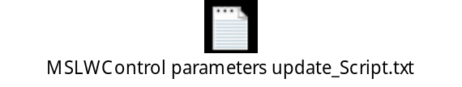
106 | TK3XLIRSQLU103 | MSLWControl Parameters (SABMART) script  - Open the script and update the correct servers name.  - Run the MSLWControl Parameters (SABMART) script on TK3XLIRSQLU103  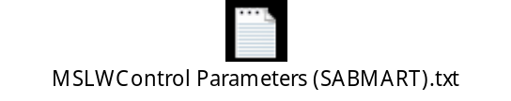
107 | TK3XSMCSQLU101 | MSLWControl Parameters (SMC)  - Open the script and update the correct server’s name.  - Run the MSLWControl Parameters (SMC) script on TK3XSMCSQLU101  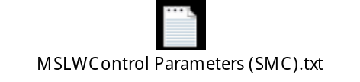
108 | KSEMCMART01 | ControlParameters (EMCCORE)  - Open the script and update the correct server’s name.  - Run the ControlParameters (EMCCORE) script on KSEMCMART01  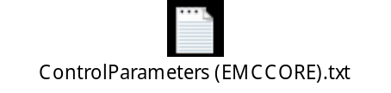
109 | TK3XLIRSQLU103 | ControlParameters (SABMART)  - Open the script and update the correct server’s name.  - Run the ControlParameters (SABMART) script on TK3XLIRSQLU103.  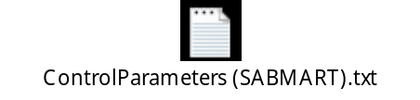
110 | TK3XLIRSQLU103 | Permissions (SABMART), SEWS,EMC WS  - Open the Script and update the sews,emc service accounts .  - Run Permissions (SABMART) script on TK3XLIRSQLU103  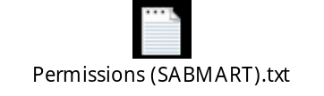
111 | TK3XLIRSQLU101 | Permissions (LIRFACTORY)  - Open the script and update the EMCCORE service Account.  - Run Permissions (LIRFACTORY) script on TK3XLIRSQLU101  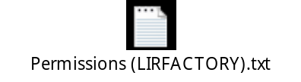
112 | TK3XLIRSQLU103 | Permissions (SABMART)  - Open the script and update the EMCCORE service Account.  - Run Permissions (SABMART) script on TK3XLIRSQLU103
113 | TK3XLIRSQLU103 | AutoActivation windows service Install on SABMART server.  - Uncompress EMC_AutoActivation folder and copy to C:\Program Files\  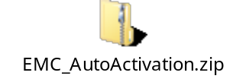  Open below .config files and update the servers name.  - AssemblyLoader.exe.config  - AutoActEmailService.exe.config  - AutoActivate.exe.config  - VellumConfigurator.exe.config  - Open cmd.exe prompt  - From C:\Program Files\EMC_AutoActivation...  - install.cmd TK3XLIRSQLU203 entitlement  Delete data from AutoActData tables  delete Entitlement.AutoActData.AutoActivation  delete Entitlement.AutoActData.AutoActivationAssemblyInfo  delete Entitlement.AutoActData.AutoActivationConfiguration  delete Entitlement.AutoActData.AutoActivationEmail  delete Entitlement.AutoActData.AutoActivationError
 | TK3XSMCSQLU101 | Registered For (SMC)  Run this script on TK3XSMCSQLU101 server.  DECLARE @userAlias varchar(100)  select @userAlias = 'PARTTEST\TK3XLIRSQLU203$' --example would be 'parttest\ksservername$'  exec Administration.RegisteredForAdd @userAlias,'4DE54C0B-2AE7-41CC-871F-C4172E40B4FC'  Verify the user &machine accounts then run the below permissions script.    Verify Permissions to Interfacing Apps.  
 | KSEMCMART01 | Register Users (EMCCORE)  - MVLS - OLS  - MVLS - SAB  - CSC -- OLS  - CSC & eOpen -- SAB  - TSC -- MSDN  - TSC -- SAB  - DAS  - eOpen  - EMC -- OLS  - EMC -- SAB  - EMC -- BPOS  - EMC -- MSA_SDA_LUA  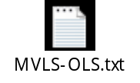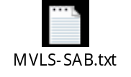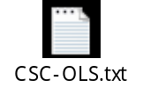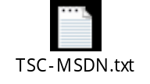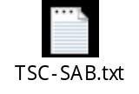  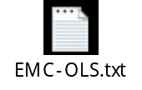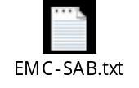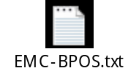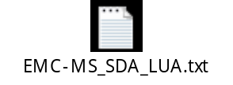  Copy Scrubbed Jobs script from SE Team to EMCCORE serve and run it in KSEMCMART01.  Configuration  - Grant Read Access to LPOUATSQL  exec sp_grantlogin [Redmond\LPOUATSQL]  use entitlement  exec sp_grantdbaccess [Redmond\LPOUATSQL], [Redmond\LPOUATSQL]  exec sp_addrolemember [db_datareader], [Redmond\LPOUATSQL]  - Confirm LIRSTEAM has updated EMCRefresh in EMC..MSLWControl with correct server name.  select * from entitlement..mslwcontrol (nolock)  where ProcessName = 'EMCRefresh'  -- point to LIRFACTORY  SELECT * FROM Entitlement..mslwControl (NOLOCK)  WHERE ProcessName = 'EMCRefresh'  UPDATE Entitlement..mslwControl  SET ServerName = 'KSLIRSQL03'  WHERE ProcessName = 'EMCRefresh'  AND ServerName = 'JUSTGSQL10'  - Check Build History (EMCCORE, SABMART)  select * from entitlement..vBuildHistory order by lastmodifieddate desc  - Apply Post Production Support Patches if necessary (SABMART,EMCCORE)

SMOKE TEST:
Instructions:
- Provide detailed steps to properly smoke test the application once the installation has been completed.
- If the web servers are in a NLB please provide instructions to do a separate smoke test on each individual node.
Step | Server | Step Instructions
 | TK3XLIRSQLU103 | Run the BVT script on SABMART Sever.

POST MAINTANENCE TASKS:
Please list all the tasks that need to be performed after the application installation has been completed. This might include items such as: sending email notification, stopping maintenance pages, updating server/application mapping in ITConfig.
Step | Server/ Activity | Step Instructions
 | KSEMCMART01 | Run Maintenance jobs  - Index rebuild  - update statistics

ENTITLEMENT DATA FLOW:
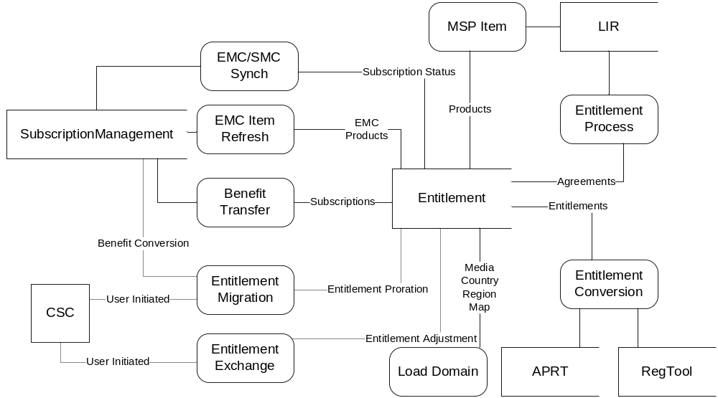

JOBS DATA FLOW:
SERVERS | SOURCE | TARGET | LEVEL | TARGET JOB DESCRIPTION
FROM | LIRFACTORY | EMCCORE
LIRFACTORY | MSLicenseDeleteprocess | EMCCOREVLDeleteSyncJob | 1 | Deletes redundant data
TO | MSLicenseOrderRefresh | EMCCoreMSLSyncJob | 1 | Pulls license related data from LirFactory
EMCCORE | OpenRefresh | EMCCoreOpenSyncJob | 1 | Pulls order related data from LirFactory
 | ShipmentRefresh | EMCCoreReportSyncJob | 1 | Pulls Open agreement data from LirFactory
 | EMCCORE | EMCCORE
EMCCORE | EMCCoreMSLSyncJob | EntitlementProcess | 2 | Calculates benefits based on purchases
 | EntitlementProcess | OrgEntitlementProcess | 2 | Calculates benefits based on purchases for SELECT PLUS agreements
FROM
EMCCORE | EMCCORE | SABMART
TO | EntitlementProcess | EntitlementProcessFinalize Job | 3 | Summarizes benefits and creates data for AutoActivation service and Benefit Transfer
SABMART
 | SABMART | SABMART
SABMART | EntitlementProcessFinalize Job | EMCSMCSync_Chunk_Step1_Initialize | 4 | Identify subscriptions to be sync with SMC application
 | EMCSMCSync_Chunk_Step2_StartWork | runs every minute | 4 | Kicks off chunk work job
 | EMCSMCSync_Chunk_Step2_StartWork | EMCSMCSync_Chunk_Work | 5 | Push data to SMC

EMCCore – SABMART DATA FLOW:
